Meeting Minutes

Week 1- September 27th
From first lecture we nominated ourselves into groups with us going away gathering ideas, hints and other interests for our own documentary.

Meeting objectives: - We firstly sorted out group roles which some of us taking on new, cunning and out of our comfort zone tasks.
- We then shared documentary ideas between each other, racking up several points as well as news articles giving us even more ideas to plan our documentary on.
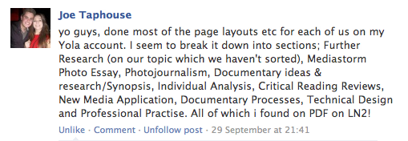
- Finally we drew a thought-shower of company names.

Week 2 – Monday 1st Oct
Members present: Monica Gameiro, Zara Kirkpatrick, Dale Stewart, Daniel Ashfield and Joe Taphouse.

Meeting objectives: Talked about each others ideas pitched to group.

Last meeting task/aims:
- Think of a production name
- Think of some ideas for the documentary

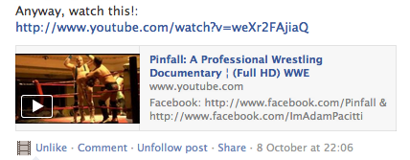

Week 3 – Tuesday 9th October
Members present: Monica Gameiro, Zara Kirkpatrick, Dale Stewart, Daniel Ashfield and Joe Taphouse.

Meeting objectives: - Discussed more ideas for the documentary.
- Vigilante documentary (disadvantages; we can't film with the subject, Vigilante being illegal it's against all rules & regulations)
- Zimbabwe displacement, following specific members of the public. Researched into Brighton, following their life stories up to now.
- Boy Racers, original but filming in the point of a view of a 17/18 year old struggling to find insurance & being stereotyped negatively.
- Fratton Park (Portsmouth F.C.), gone into liquidation. The struggle of the company & the fans.
- Plastic Surgery Documentary, find the reason for public to undertake surgery, pros & cons etc.
- Student demos documentary
Discussed the amateur wrestling documentary.
- Go away and watch Grizzly man for codes & conventions.
Members present: Monica Gameiro, Zara Kirkpatrick, Dale Stewart, Daniel Ashfield and Joe Taphouse.

Next Week Task: Pitch Photo Essay Ideas to group

Week 4 – Monday 15th October
No meeting this week, due to members being busy with other work.

Week 5 –Monday 22nd October
All group pitched ideas for their Photo Essays and we all discussed what we thought about each other’s ideas, giving feedback. All got given TABS to do.

Next Week Task: Start to add work to TAB’s on Yola site, get to know how to use it and understand it. All start to find primaries for individual Photo Essays if not done yet.

Week 6 – Monday 29th October
Check up on group work on Yola, lacking work because people have been concentrating on other groups and other deadlines. Check up on Photo Essays and progress with editing.

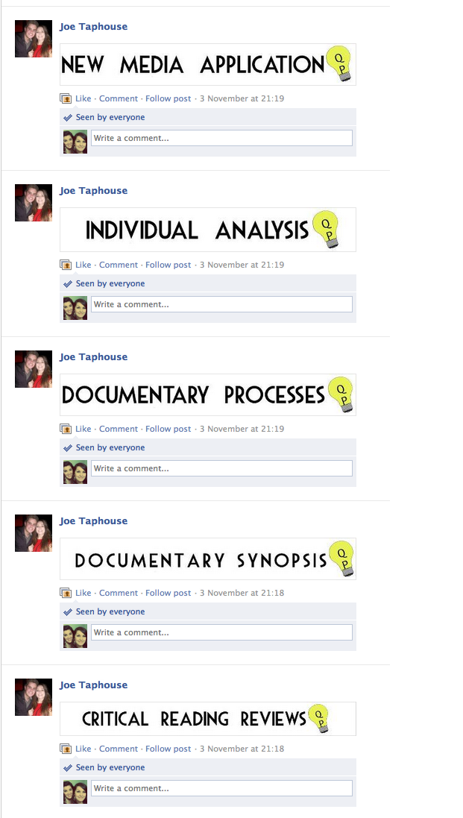
Next Week Task: Joe to make buttons for Yola. Final editing of photo essays. Keep adding to the website on given workbook pages as well as individual pages.

Week 7 – Tuesday 6th November
Handed in Photo Essays and Technical images for marking. Contacted – emailed primaries for documentary travelling fair idea.

Next Week Task: Try to get an answer from a primary, get them on board.

Week 8 – Monday 12th November
All worked on website.

Week 9 – Monday 19th Nov
Members present: Monica Gameiro, Zara Kirkpatrick, Dale Stewart, Daniel Ashfield and Joe Taphouse.

Last meeting task/aims:
- Watch documentaries as research, Watch Tupac and Biggie documentary.

Next Weeks task/ aims:
1) To get on top of working on the website, each member to aim to complete their two weeks reviews for Further Research TAB in workbook.
2) To write up three top documentary ideas on synopsis TAB and each member review each idea.
3) Make sure that everyone’s TAB’s on their pages are linked.
4) Contact people from top three ideas, asking if they would be interested in being part of our documentary.
5) To have a finalised documentary idea, that would be our main idea, with two backups.

Week 10- Monday 27th Nov
Members present: Monica Gameiro, Zara Kirkpatrick, Dale Stewart, Daniel Ashfield and Joe Taphouse.

Tasks completed since last week:
- Almost all of group have done at least their first week.
- Synopsis written up and most reviews done.
- All TAB’s linked.
- Contacted all top 4 possible ideas
- Still need to finalise idea.

Meeting Agenda:
- Check what stage everyone is at, making sure everyone is on a similar page and if they have completed set tasks from previous week.
- Go over website and see what members have completed and what is yet to complete.
- Discuss continuity of website and overall style.

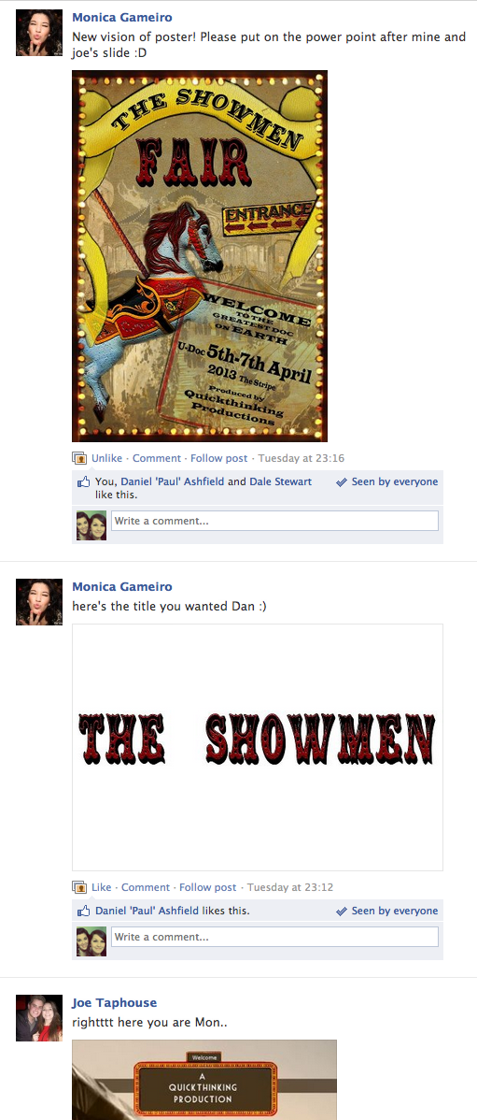

Week 11 – Monday 3rd December
All working together in MMC.

Week 12 – Monday 10th December

All working together in MMC.

